Dear Parents/Carers,

Walking Home Alone – Year 5 and 6 Pupils only

We understand the need for children in Years 5 and 6 to begin to develop their independence as part of their preparation for high school. Please can parents who are happy for their child to walk home alone sign the ‘walk home permission slip’ and return it to school. I would strongly advise that children in other year groups should not walk home alone. We will not let children go home alone at the end of the day unless we have received written permission.

Here are a few things that you may wish to discuss with your child:

Stick to a well-lit and used route.

Wear bright/reflective clothing.

Be vigilant at all times.

Thank you for your continuing support.

Yours sincerely,
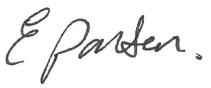
Head teacher
__________________________________________________________________________________

WALK HOME PERMISSION SLIP FOR YEARS 5 AND 6.

Name of child___________________________________________ Class___________________

I give permission for my child to walk home from school alone.

Signed________________________________________ Date_________________________

