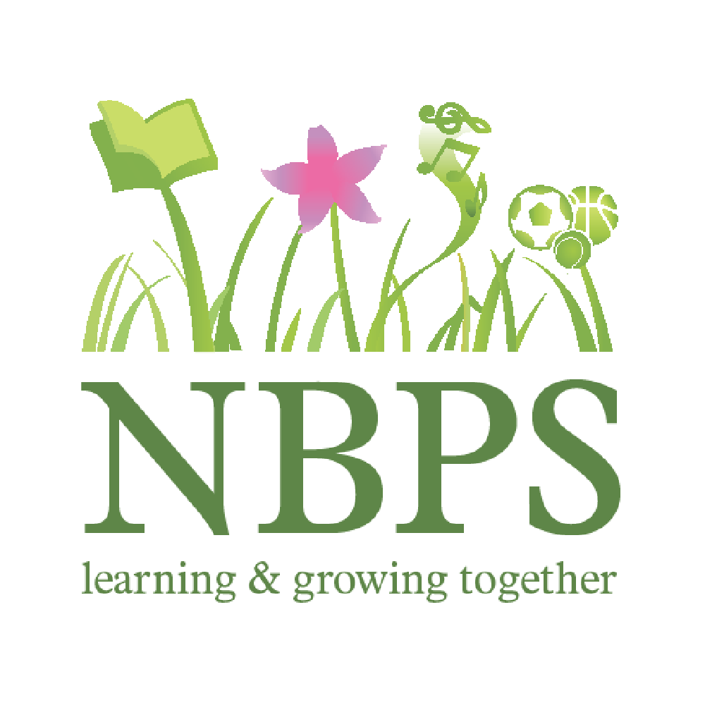
Yearly curriculum overview
Year Group: 3
 | Autumn 1 | Autumn 2 | Spring 1 | Spring 2 | Summer 1 | Summer 2
No of Weeks | 8 | 7 ½ | 5 ½ | 6 | 6 | 6
GROW value | Goals | Ownership | Respect | Goals | Respect | Working together
Learning Value | Challenge | Responsibility | See different points of view | Taking risks | Kind words and actions | Share and compromise
Topic Name | What does it mean  to be civilised?  (Ancient civilisations) | Tomb Raiders!  (Egyptians) | Toro! Toro!  (Big Arts - Spain) | May the force be with you!  (Forces including magnets) | Home and away!  (Contrasting locations - Castleton) | Stone age rocks!  (Little Nose by John Grant)
Hook | BBC film - Lost Lands | Eqyptian-themed open day - DEAL | Ready steady cook - Food tasting | Investigate a range of magnetic toys | Residential to Castelton | DEAL  (using the forest area)
Final outcome | Make artefacts from the 4 civilizations for a pop-up museum | Design and create a non-fiction book about an aspect of an Ancient Civilisation | Big Art Exhibition | Science fair | Create a presentation for next year’s Y3 all about Casteton | :Little Nose Story Time  Write a story for a younger child
Lead subjects | History | History | Art | Science | Geography | Book led  History  Science
Supporting Subjects | DT  Geography  Computing | Computing  Art  Geography  DT | English  Spanish  DT  Music | English  Art (magnetic art) | English  Computing | Geography  Computing  Art  English
Stand-alone Subjects | Maths  PHSE  Spanish  English  PE  Music | Maths  PHSE  Spanish  English  PE  Music | Maths  PHSE  PE  History  Geography  Computing | Maths  History  Geography  PE  Music  DT  Spanish | Spanish  Maths  Art  DT  Music  History  PHSE  PE | DT  Music  PHSE  Maths  PE
Computing | Program a Probot to follow a route between two Sumerian cities | Coding - Create an Eqyptian themed maze game | Graphs  (Purple Mash) | Online safety | Simulations | Google slides  Hyperlinks  Coding  Touch typing
Outdoor | Mud bricks  Plants/trees observations | Forest school | Forest school  Plants/trees | Forces in nature | Residential to Castelton  Orienteering | Create shelters  Outdoor cooking  Bow and arrows

