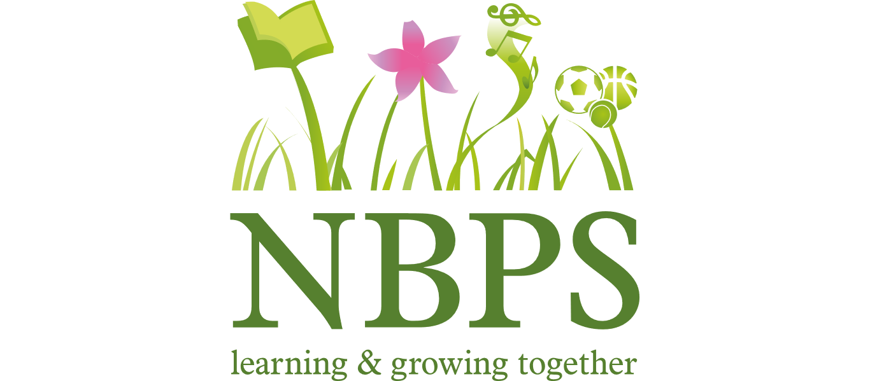

Remote Learning Policy
A110

Produced by | Norris Bank Primary School
Date approved and agreed by Governing Board | 30th November 2020
Review Date | November 2022

Rationale for Remote Learning
After consideration of Department for Education guidance on the occasion of children being asked to self-isolate for a period of time during the COVID-19 pandemic, we are making specific provision available for their home learning. Children will be asked to self-isolate and learn from home if:
- They are well, but having to self-isolate for 10 days with the rest of their bubble following a confirmed case of COVID-19.
- They are well, but having to self-isolate for 10 days following a confirmed case of COVID-19 with a family member/ contact outside of school.
- They are well but having to isolate for a few days while awaiting a household test result.
Arrangements for Remote Learning for a Bubble
The following activities will be put in place when a bubble has to self-isolate for 10 days following a confirmed case of COVID-19.

Key Stage | Activities | Daily expectations
Reception | - A blend of interactive, work sheet and independent learning as well as links to appropriate educational websites and videos.  - Learning to cover a daily phonics/reading/writing session by video and maths supported by purple mash and Mathletics.  - Activities linked to Understanding of the World/ Expressive Art and Design and Physical Development.  - Daily reading of books from school or from home or online with an adult 10-15 mins.  - These activities can be accessed via the school VLE on the website as well as the use of Dojo. | 1 to 2 hours
KS1 | - A blend of interactive, work sheet and independent learning as well as links to appropriate educational websites and videos.  - Year 1 & 2 will use the dojo as well as the class story element  - English such as phonics, reading and writing, math’s and other curriculum subjects will be delivered via google classroom, Purple mash, white rose math’s and other appropriate apps such as Mathletics.  - Focus on creative curriculum, science, PSHCE and PE  - To support wellbeing: staff will use a range of strategies including the app ‘explain everything’ which will allow the children to hear their class teacher.  - Regular check ins/outs with the children will happen  - Teachers will read to their children.  - Learning grids covering the topics covered will be able to be accessed via the school website.  - Daily reading of books from school or from home with an adult 10-15mins. | 2 to 3 hours
KS2 | - A blend of interactive, work sheet and independent learning as well as links to appropriate educational websites and videos.  - The use of dojo and class story  - English such as reading, writing, math’s and other curriculum subjects will be delivered via google classroom, Purple mash, white rose math’s and other appropriate apps such as Mathletics, TT Rock stars etc..  - Focus on creative curriculum, science, PSHCE and PE  - Session may include tutorials and online videos.  - To support wellbeing: staff will use a range of strategies including the apps ‘loom’ and ‘explain everything’ which will allow the children to hear their class teacher.  - Regular check ins/outs with the children will happen  - Learning grids covering the topics covered will be able to be accessed via the school website.  - Weekly PSHCE lesson  - Weekly PE lessons  - Independent reading of books from home or from school fro 10-15mins  - Reading lessons throughout the week | 3 to 4 hours
No internet access | - Where children do not have internet access at home, a printed pack of resources will be provided at the start of the period of self-isolation.

- All children in have a Google classroom ID and password. This information will be sent home again if required.
- Children have access to a range of learning platforms which may be year group specific e.g. Purple Mash, Mathletics, TT Rock Stars. Copies of passwords and login details will be sent home again of required.
- Teachers will provide appropriate work for the children in their classes, including adapted work for children with additional needs. This may require support from our SEN teacher.
- Our SEN Teacher will provide appropriate work for our most complex SEND children.
Keeping in touch with a bubble who are self-isolating
- Where teachers are well and able to do so, they will keep in regular contact with the children in their class to ensure that they are accessing the learning and are well.
- If children have not accessed the work or had contact with their teacher at some point each week they will receive a phone call to check in with them.
- Where children are identified as not accessing the work online, printed packs of work will be made available.
Arrangements for Remote Learning for Individual children
Where a child is self-isolating for up to 10 days whilst their class is still in school, the following arrangements will be in place.
- For all year groups resources, independent access to lessons and activities will be made available on the VLE for the period of self-isolation. This will cover a range of lessons including English, Maths and reading.
- A pack or work can also be sent home if they are unable to access the VLE
Further Resources for Remote Learning
- Our school website also lists a range of websites and resources which can be accessed using the following link:
http://norrisbank.stockport.sch.uk/useful-resources/

