Green Lane Heaton Moor Stockport SK4 2NF
Tel: 0161 432 3944 Fax: 0161 975 5114 www.norrisbank.stockport.sch.uk
Headteacher: Mrs Elena Ponsen

Friday February 11th 2022

Hadrian’s Wall Residential 2022
Dear Parent/Carer,
The cost of the Year 4 trip to Hadrian’s Wall has now been finalised.
The 3 day trip is from Wednesday 13th July to Friday 15th July 2022 and will cost £155, with 57 children attending. The cost includes all food, coach travel, accommodation, activities and supervision at the centre for 3 days and 2 nights. Please be aware that if the number of children is below 57 the cost of the trip will increase accordingly as the coach price will remain the same.
A £20 non-refundable deposit is required to secure your child’s place to be paid by Friday 4th March. The balance is due by Friday 10th June. All payments are to be made via ParentPay under the heading, ‘Year 4 Northumberland Residential 2022’. After the initial deposit, any amount can be paid at any time up to Friday 10th June. All consents are on ParentPay so please complete these when making the deposit.
As stated at the meeting, if your child’s behaviour indicates that they would put themselves or other children’s safety at risk, you will be informed by letter. If their behaviour shows no improvement, your child will not be able to attend and any money paid may be forfeited.
Yours sincerely,

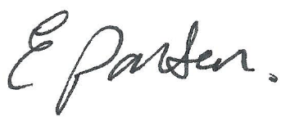

Mrs E Ponsen

