

**D10a Reporting Low Level Concerns Policy**

|  |  |  |
| --- | --- | --- |
| Date of Update | Reason for Update | Next Update |
| Sept 2022 | This was recommended within the Stockport model safeguarding policy for | Sept 2024 |

**Contents**

1. Introduction

2. Summary

3. Keeping Children Safe in Education September 2022

4. Clarity around Allegation vs Low-Level Concern vs Appropriate Conduct

5. Storing and use of Low-Level Concerns and follow-up information

6. Process to follow when a Low-Level Concern is raised

7. Low Level Concern Form

**1. Introduction**

At Norris Bank Primary School, we aim to create an open and transparent culture where all concerns about all adults involved with our school are dealt with promptly and appropriately. We aim to identify any concerning, problematic or inappropriate behaviour early; minimise the risk of abuse; and ensure that adults working in or on behalf of our school are clear about professional boundaries and act within these boundaries, and in accordance with our school ethos.

This policy should be read alongside our Safeguarding and Child Protection Policy and Staff Code of Conduct.

**2. Summary**

It may be possible that a member of staff acts in a way that does not cause risk to children, but is however inappropriate. A member of staff who has a concern about another member of staff, volunteer, contractor or who, on reflection, recognises that their actions could have been viewed as a risk should inform the Headteacher about their concern using a Low-Level Record of Concern Form.

If the Headteacher cannot be contacted, the Chair of Governors should be contacted instead.

**\*NB – if the concern is about the Headteacher, then the Chair of Governors should be informed.**

**3. Keeping Children Safe in Education September 2022**

The following is taken from Keeping Children Safe in Education September 2022 and identifies what may be considered behaviour relating to low level concern:

***426 What is a low-level concern?***

*The term ‘low-level’ concern does not mean that it is insignificant. A low-level concern is any concern – no matter how small, and even if no more than causing a sense of unease or a ‘nagging doubt’ - that an adult working in or on behalf of the school or college may have acted in a way that:*

* *is inconsistent with the staff code of conduct, including inappropriate conduct outside of work and*
* *does not meet the harm threshold or is otherwise not serious enough to consider a referral to the LADO.*

*Examples of such behaviour could include, but are not limited to:*

* *being over friendly with children*
* *having favourites*
* *taking photographs of children on their mobile phone, contrary to school policy*
* *engaging with a child on a one-to-one basis in a secluded area or behind a closed door, or*
* *humiliating children.*

*427. Such behaviour can exist on a wide spectrum, from the inadvertent or thoughtless, or behaviour that may look to be inappropriate, but might not be in specific circumstances, through to that which is ultimately intended to enable abuse.*

*428. Low-level concerns may arise in several ways and from a number of sources. For example: suspicion; complaint; or disclosure made by a child, parent or other adult within or outside of the organisation; or as a result of vetting checks undertaken.*

*429. It is crucial that all low-level concerns are shared responsibly with the right person and recorded and dealt with appropriately. Ensuring they are dealt with effectively should also protect those working in or on behalf of schools and colleges from becoming the subject of potential false low-level concerns or misunderstandings.*

**4. Clarity around Allegation vs Low-Level Concern vs Appropriate Conduct**

*‘It is important to recognise that, in practice, the words ‘concern’ and ‘allegation’ can be and are used interchangeably by different people. Sometimes individuals may shy away from the word ‘allegation’ and express it as a ‘concern’ instead. The crucial point is that whatever the language used, the behaviour referred to may, on the one hand, be capable of meeting the harm threshold (and hence be referable), or, on the other, it does not meet the harm threshold (in which case it should be treated as a low-level concern). So, the focus should not be on the language used by the person disclosing it; the focus should, instead, be on the behaviour being described.’*

Farrer & Co. September 2022

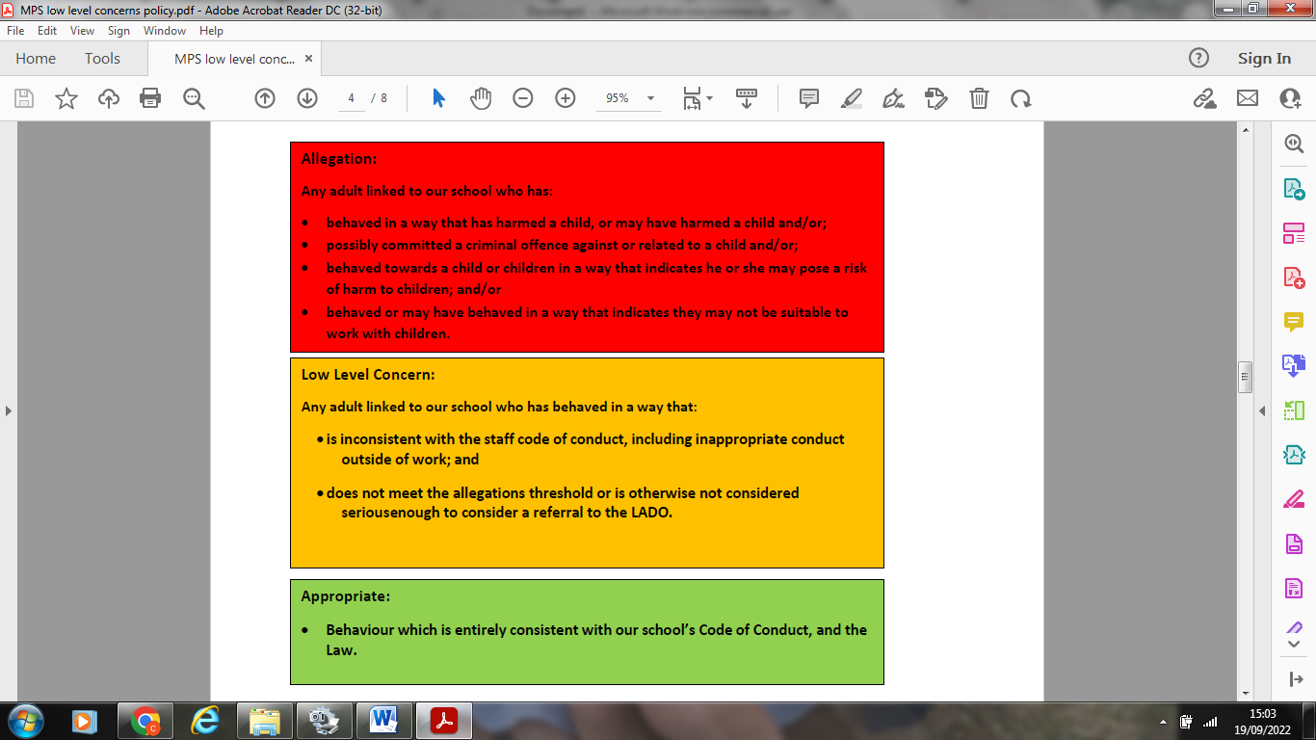

**5. Storing and use of Low-Level Concerns and follow-up information**

Low-Level Concern forms and follow-up information will be stored securely within the schools safeguarding systems, with access only by the leadership team. This will be stored in accordance with the school’s GDPR and data protection policies. The staff member(s) reporting the concern must keep the information confidential and not share the concern with others apart from the Headteacher or those aware on the senior leadership team.

Low-Level Concerns will not be referred to in references unless they have been formalised into more significant concerns resulting in disciplinary or misconduct procedures. Whenever staff leave Norris Bank Primary School, any record of low-level concerns which are stored about them will be reviewed as to whether or not that information needs to be kept.

Consideration will be given to:

(a) whether some or all of the information contained within any record may have any reasonably likely value in terms of any potential historic employment or abuse claim so as to justify keeping it, in line with normal safeguarding records practice; or

(b) if, on balance, any record is not considered to have any reasonably likely value, still less actionable concern, and ought to be deleted accordingly.

**6. Process to follow when a Low-Level Concern is raised**

|  |
| --- |
| **\*NB – if the concern is about the Headteacher, then the Chair of Governors should be informed.** |
|  |
|  |
| **7. Low-Level Concerns Reporting Form – Norris Bank Primary School**   |  |  |  | | --- | --- | --- | | **Your Details** | | | | **Name** |  | | | **Role** |  | | | **Date and time of completing this form** |  | | | **Details of individual (including yourself if self-reporting) whom the concern is about** | | | | **Name** |  | | | **Role** |  | | | **Relationship to the individual reporting (e.g. manager, colleague)** |  | | | **Details of concern** | | | | **Please include as much detail as possible. Think about the following:** What behaviour and/or incident are you reporting? What exactly happened? Why does the behaviour and/or incident worry you? Why do you believe the behaviour and/or incident is not consistent with our Staff Code of Conduct? | | | | **Details of any children/young people involved** | | | | **Name (s)** |  | | | **Next Steps** | | | | **Are you willing to meet with the Headteacher and DSL to discuss your concern?** | **Yes** | **No** | | **Please state any other information that you feel is relevant to the processing of this concern** |  | | | **Signature** |  | | | **For use by HT/safeguarding team upon receipt of the concern** | | | | **Date and time concern received** |  | | | **Signature** |  | | | **Role** |  | | | **Actions to be taken and follow-up** |  | | |